# ConsumerVPN Client for iOS 14.0+

## Getting Started Guide

1. Install the latest CocoaPods and run `pod install` from the root directory of the project
2. Open the build settings for the project App target
   1. Change your Bundle Identifier to a unique value
   2. Select your Signing Identity

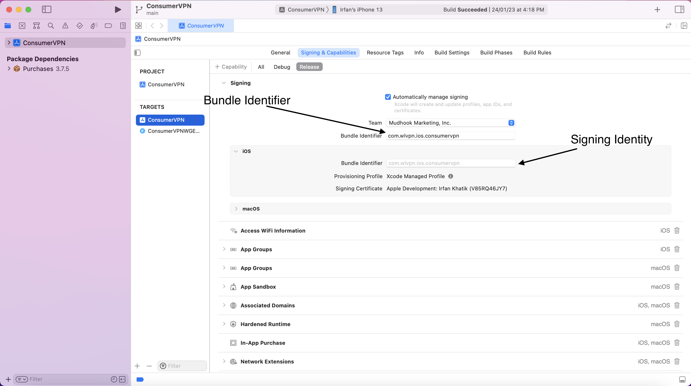

1. Open the build settings for the project WireGuard Network Extension target
   1. Change your Bundle Identifier to a unique value
   2. Select your Signing Identity

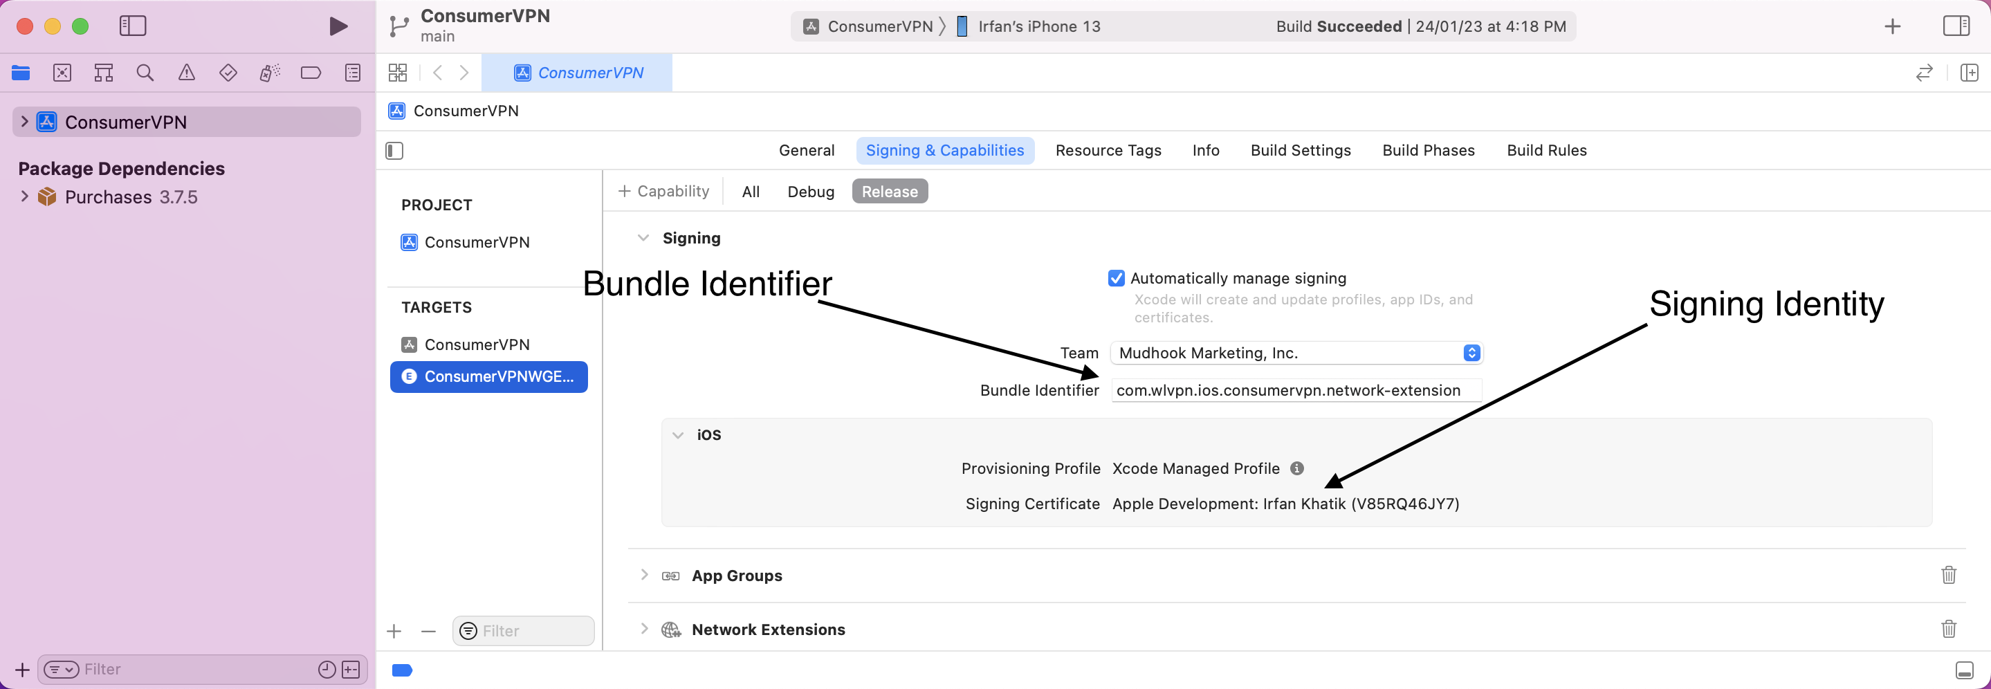

1. Select “Build Phases” 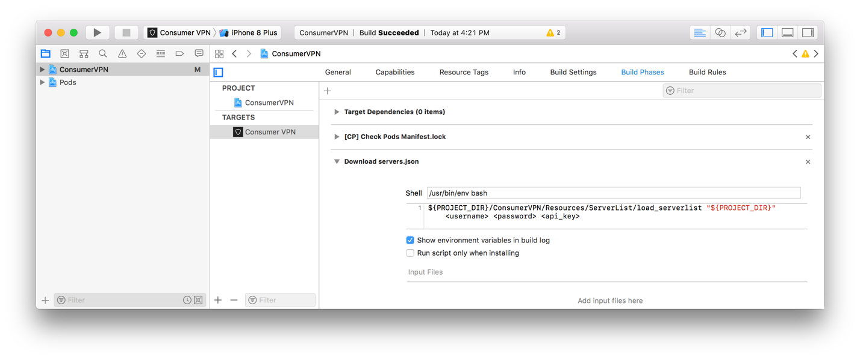
   1. If you have a demo account, enter your username, password, and api key into the placeholder values.
   2. If you do not have a demo account yet, check the box “Run script only when installing”
2. Checkout Theme submodule.
   1. git submodule init
   2. git submodule update
3. Open the Theme.swift file and replace the following values:
   1. productName
   2. brandName
   3. configurationName
   4. forgotPasswordURL
   5. contactSupportURL
   6. usernameSuffix
   7. apiKey
4. Customize the colors in Theme.swift